Bacteria Review
Directions: Use the bacteria notes from class and the bacteria reading (48-53) to answer the following questions.

- Bacteria cell are _____________________. The genetic material in cells is not contained in a nucleus.

- Are bacteria unicellular or multicellular?

- What three shapes can bacteria cells have?

___________________________ _____________________ ______________________

Compare and Contract the bacteria cell to the plant cell.

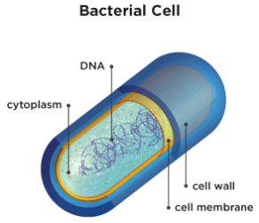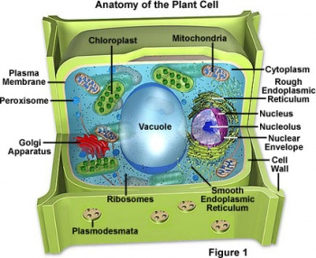

- What are some differences between the plant cell and bacteria cell?

- What are some similarities between the plant cell and bacteria cell?

- What are the types of conditions that help bacteria to thrive, grow, and reproduce? (Hint: Look at page 52 in reading and think about bacteria lab)

- What is binary fission (asexual reproduction) in bacteria cells? (Hint: Look at page 52 in reading)

- How is asexual reproduction different than sexual reproduction in living things? (Hint: Look at page 52 in reading)

- Give an example of how bacteria is helpful. (Hint: Use Bacteria Notes)

- Give an example of how bacteria is harmful. (Hint: Use Bacteria Notes)

