**Fossil Record Assignment**

**Learner Outcomes:**

* The student will be able to analyze data from the fossil record (graphs and charts) and create a diagram to show how fossils would appear through relative dating (MS-LS-4-1).
* The student will be able to analyze the diagram of relative dating to explain the differences and similarities in anatomy among organisms inferring evolution (MS-LS-4-2).

**Directions:**

1. We have spent some time learning about the characteristics of animals. Now we will apply that information in understanding how these animals formed over time. Read pages 107-111 in the animal book. Look at the geologic timeline chart and pattern of evolution chart.
2. Use the template on the back side of this paper as your practice copy to help create your final copy on construction paper.
3. Use the following labels for each of the rock layers represented. Make sure the labels are in the correct sequence (bottom to top).

* **Jawless Fish**: 500 Million Years Ago
* **Cartilaginous Fish/1st Bony Fishes** (Lobed-Finned Fish): 425 Million Years Ago
* **Earliest Amphibians:** 350 Million Years Ago
* **Earliest Reptiles:** 275 Million Years Ago
* **Earliest Mammals:** 225 Million Years Ago
* **Dinosaurs (T. Rex & Triceratops)/First Birds (Archaeopteryx):** 140 Million Years Ago
* **Modern Mammals and Modern Birds:** 1.5 Million Years Ago to Present

1. Cut out the animals on the attached page. Create a diagram showing how these vertebrate animals may have formed in rock layers over millions of years. Glue the animals in the correct sequence (rock layers) in showing how the fossils may have formed. Make sure that each rock layer is labeled. A total of seven rock layers should be present.
2. Answer questions regarding how these animals formed fossils in these rock layers over time. Glue the page with your answers to the back of your diagram.

Animals of Fossils in Rock Layers over Millions of Years

|  |
| --- |
|  |
|  |
|  |
|  |
|  |
|  |
|  |

**Questions Regarding Diagram**

**(Inferring Evolution Questions)**

1. What do you notice about lobed finned fish that infer the evolution of amphibians?
2. How does the skin of amphibians look different than the skin of reptiles? How did this help with the evolution of reptiles?
3. According to the diagram created, name the two classes of animals that evolved from reptiles.
4. What characteristics does the earliest bird (Archaeopteryx) share with both reptiles and birds (Hint: page 118)? What does this tell us about birds?
5. According to the diagram, what happened to the mouths of fishes between 500 million years and 400 million years? What change do you notice?
6. What characteristics do the earliest and present mammals share?
7. How are modern mammals different than the earliest mammals?

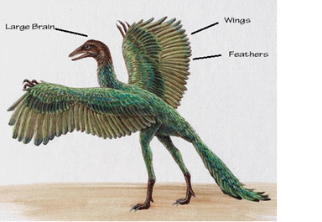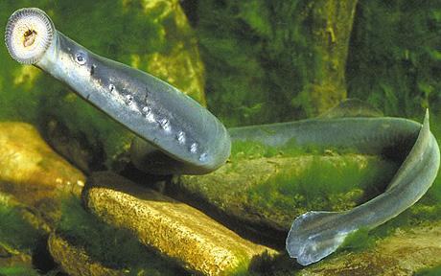

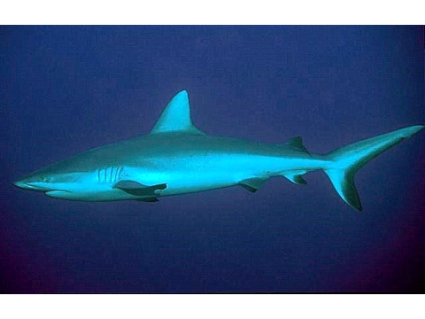 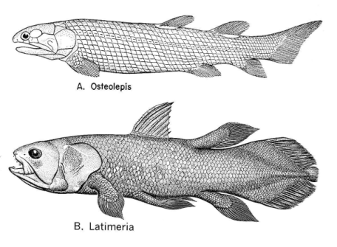

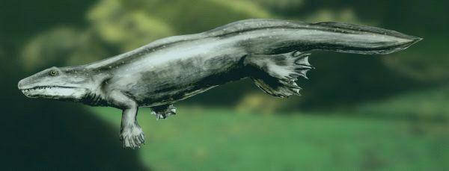 Ichthyostega 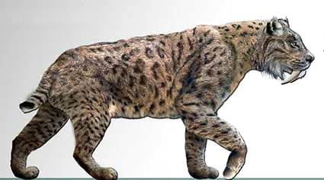 saber tooth

(swimming)

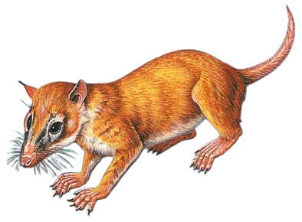 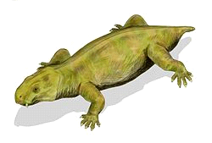Dicynodon

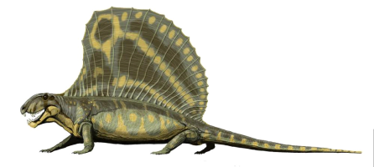 Dimetrodon 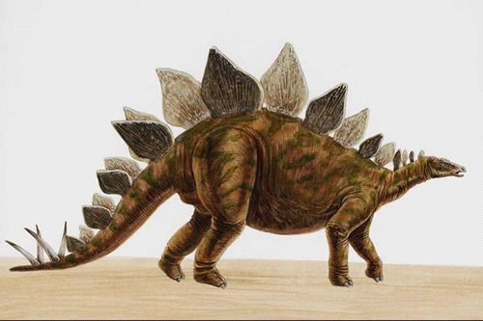 Stego.

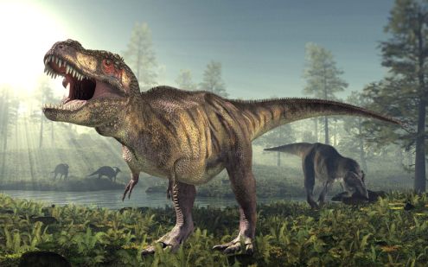 T. Rex 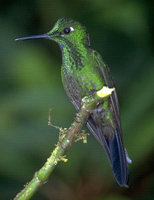

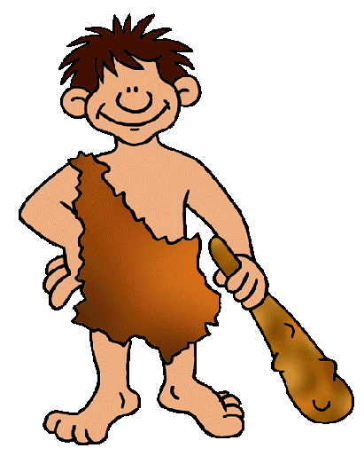human